Reflecting

From your journey with this passage, you are now invited to reflect, and put into your own words, any new insights or understanding that you have received (Wisdom moment).

From your journey with the passage, what

Children
Reading
John the Baptist has spent his life preparing the people of his time for the coming of their Sav- iour. He is dedicating his life to emphasising the uniqueness and greatness of another person. John is eager for people to recognise Jesus, the lamb of God, who is offering something much more than he is, because He is filled with the Holy Spirit.

Recognising
Can you remember a time when you were like John the Baptist and you were willing to take the back seat so that someone else, with some- thing valuable to offer, could receive attention?

Can you remember a person like John the Bap- tist - a parent, grandparent, priest or teacher,- who devoted their life to pointing you to the uniqueness and greatness of Jesus?

Responding
Father, I thank you for the example of people in my life who have been willing to set aside their own interests for the good of others, and for

new insight or understanding has been given to you into the truth of honesty, or humility, or power over evil? It might read something like this:The only way to overcome evil is through the power of goodness.This is only a sample.Try to uncover and express your own personal insight.

those who have handed on the faith to me.

Father, I am sorry for the times that I have missed the opportunity to allow another per- son to be recognised and appreciated, and for the times that my words and actions have not pointed others to the greatness of Jesus.

Father, I ask that you grant me the humble heart of John the Baptist which allows me to be inspired by encouraging others to succeed, and fill me with your Holy Spirit so that my words and actions point to Jesus.

Resting
Rest in the gentle embrace of the Father by repeating “LAMB OF GOD” for as long as it is possible. May you be filled with all the inspira- tion that comes from resting in the Spirit-filled presence of the Father.

Reflecting
The purpose of life is found in pointing to the greatness of others.

Living the tford
MEDITATING ON THE SUNDAY GOSPEL
LECTIO DIVINA

Gospel: John 1:29-34
29The next day, seeing Jesus coming towards him, John said,“Look, there is the lamb of God who takes away the sin of the world. 30This is the one I spoke of when I said: A man is coming after me who ranks before me

“...who takes away the sin of the world.”

2nd Sunday in Ordinary Time
A resource for personal, family and community prayer.

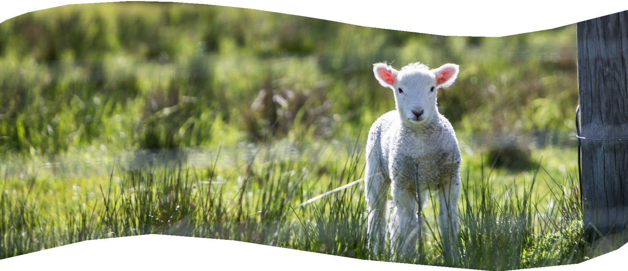
You are invited to read the Gospel passage attentively, respectfully and reverently as a gift of God.

“the lamb of God...”

because he existed before me. 31I did not know him myself, and yet it was to reveal him to Israel that I came baptising with water.” 32John also declared, “I saw the Spirit coming down on him from heaven like a dove and resting on him. 33I did not know him myself, but he who had sent me to baptise with wa- ter had said to me, ‘The man on whom you see the Spirit come down and rest is the one who is going to baptise with the Holy Spirit’. 34Yes, I have seen and I am the witness that he is the Chosen one of God.”

A simple summary of Lectio steps can be found in the porch of the church.
For more information check out https://lectio.newrydominican.com which includes this week’s
Sunday Gospel podcast ‘Meditate on the Way’. 028 3026 2178 l lectiocentre35@gmail.com

Reading

v32. “I saw the Spirit coming down on

him from heaven like a dove and resting

For John the Baptist, Jesus is the lamb of God who takes away the sin of the world. In oth- er words he is actively engaged in overcom- ing the evils in our world (in our personal lives and in our culture) of individualism, racism, elitism and indifference. Jesus has a distinctive way of taking away sin by being the “lamb of God” – no violence in him at all, and a readiness to accept the suffering involved on the way.

on him.”
Can you enter into the passage by remem- bering a time when you were challenged to take a closer look at someone in your life
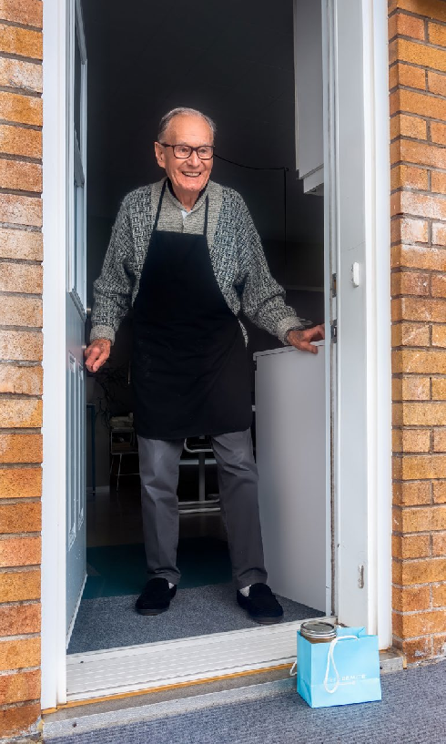
– to recognise the person as sacred, as a gift from God, as someone doing the work of God?

Gracious Father, open our eyes to see “the lamb of God who takes away the sin of the world” at work among us today.

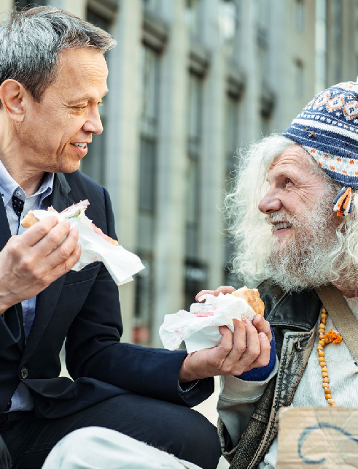
John is filled with a certain awe and rever- ence in the presence of Jesus – recognising the presence of God in him. He humbly acknowledges that he has only gradually come to appreciate who he really is. And more than that, he accepts that Jesus will do greater things than he has ever done.

Heavenly Father, we ask forgiveness for
the times we continued to pretend that we knew it all.
Gracious Father, open our eyes to see “the lamb of God who takes away the sin of the world” at work among us today in those who are trying to overcome the many evils of selfishness, domination and indifference that plague our world.

Recognising

You are invited to meditate on the pas- sage, or any part of it, by letting it speak to your life experience until you feel to say “I recognise this passage.”

v29. “Look, there is the lamb of God who takes away the sin of the world.”
Can you enter into the experience of John the Baptist by remembering people actively engaged in the struggle against evil in our society – people who are prepared to lay down their lives for the cause if needs be?

Jesus is the lamb of God who takes away the sin of the world. In other words
he is actively engaged in overcoming the evils in our world of individualism, racism, elitism and indifference.

v30. “A man is coming after me who ranks before me”
Can you enter into the experience of the Baptist by remembering a time when your heart was filled with great hope in knowing that there were others coming after you who would continue the work you had begun, do even greater work and bring it to comple- tion?

Resting

You are invited to enter deep prayer by simply resting your heart in God’s presence (Contemplative moment). The quiet repe- tition of a word or phrase from the passage might help you on this journey into greater silence and stillness, e.g. “Lamb of God”.
Responding
Having recognised God’s presence in life, you are invited to respond in your own words, in prayer (thanksgiving, repentance and petition).

We thank you, Father, for those who rec- ognise and acknowledge their limitations yet continue to do the task assigned to them -“baptising with water” - trusting that there will be others who will come after who will “baptise with the Holy Spirit.”

Heavenly Father, we ask forgiveness for the times we continued to pretend that we knew it all, that we had all the an- swers, not accepting our limitations and the truth that “there is one coming after us who ranks before us.”

