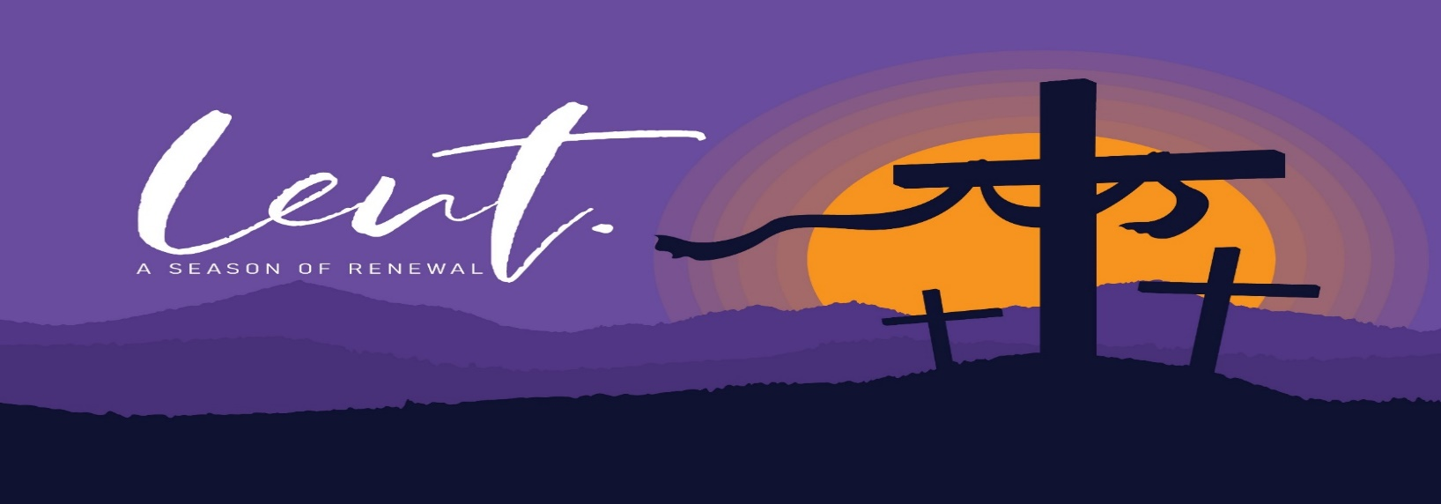**Journeying with the Word of God Lent**

The Lenten series for Newcomers presented by Fr Joseph Ralph OP

begins

**(In Person) Monday 20th February** **at 7pm**

Or

**(Online) Thursday 23rd February at 8pm**

and continues for six weeks.

For further information and to book a place,

please contact the **Lectio Centre, Newry** with preferred option.

(Numbers are limited)

**T**.028 302 62178 (**Mon-Sat** 10-5pm)

**E**. [lectiocentre35@gmail.com](mailto:lectiocentre35@gmail.com)

Further resources:- lectio.newrydominican.com